New Faculty Retreat

Thursday, August 18, 2022

10:00 am – 3:30 pm

Hybl Sports Medicine & Performance Ctr Rooms 225 and 450
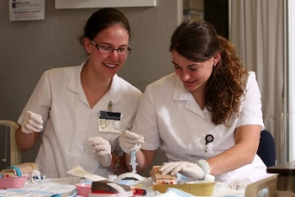
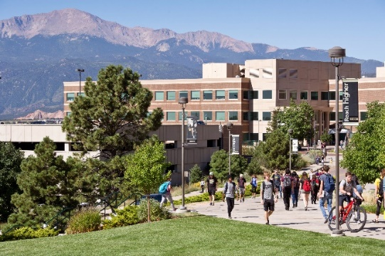

August 18, 2022

Interactive Notebook
Welcome New Faculty,
Your first few weeks as a University of Colorado Colorado Springs (UCCS) faculty member may be overwhelming and even a bit challenging. Preparing to teach new classes and familiarizing yourself with your new surroundings will keep you pretty busy!
The New Faculty Retreat is designed to provide new faculty members with information about teaching at UCCS in hopes of a smooth transition to teaching on campus. Throughout the academic year, you will have several opportunities to engage in collegial dialogue with other faculty, including GIFT Exchanges, Teaching Circles, Mountain Lion Teaching and Learning Days, and other activities offered through several Centers on campus.
This interactive notebook is designed to help you organize information from the different sessions and to articulate how those ideas might be implemented into your own teaching. As you complete this notebook, take time to reflect on your current ideas on teaching, share your thoughts with others, and get feedback from your colleagues. Our hope is that this event helps to make your transition to teaching at UCCS a smooth and enjoyable experience.
The Excel Centers (excel.uccs.edu) and the Faculty Resource Center (frc.ucces.edu) offer several resources that can help support you in your teaching. Our centers are faculty-focused, collaborative endeavors that promote and support effective teaching through creative approaches to faculty-student engagement, quality course design and implementation, and seamless integration of technology into the academic environment.
We are committed to your success at UCCS! Feel free to visit our websites or stop by the offices and ask about our services.
David Anderson
Director, Faculty Resource Center
Jerry Phillips
Executive Director, Excel Centers

One Minute Paper
Give yourself one minute to write a response to the following three questions:

Why do you want to be a faculty member?

What do you think you will enjoy most about teaching?

What do you think will be most challenging about teaching?

Opening Session

Connecting Students with Faculty and Campus: Strategies for Student Success
Use this space to list any new ideas or strategies for connecting students with faculty and the campus to consider as you teach UCCS students.
What relationship-building strategies do I plan to implement to build relationships with students?

Instructor-student relationships:

Student-student relationships:

How do I plan to foster student connections with the campus community?

What support do I need to implement these plans and who/what can assist?

Student Support and Campus Resources Breakout Session Option 1

Supporting First-Generation Students
Use this space to list new ideas and plan strategies for supporting first-gen students at UCCS.

Strategies offered for supporting first-gen students:

Ways I plan to support and value first-gent students:

What support do I need to implement this plan and who/what can assist?

Student Support and Campus Resources Breakout Session Option 2
Good Teaching is the Result of Carefully Planned Curriculum, Instruction, and Assessment
Use this space to reflect upon and deepen the interconnections between curriculum, instruction, and assessment.
List your curriculum goals for a given course:

What instructional methods do you typically use?

In what ways are they aligned with your curriculum goals and how you assess students?

What gaps do you feel exist between your curriculum goals, instructional methods, and learning assessments?

What are some strategies you could implement to maximize student success?

What support do you need to implement these strategies, and who/what can assist?

Teaching Fellows Breakout Sessions

Option 1
Making Headlines and Memes
Use this space to plan ideas or strategies for encouraging active reading, writing practice, and oral communication using headlines and memes.
Where could Making Headlines and Memes work in my course(s)?

To what degree would the assignment need to be customized to best fit into my course(s)?

What support do I need to implement this assignment, and who/what can assist?

Teaching Fellows Breakout Session

Option 2

Empowering Students’ Voices: Engaged Writing Through the “Dunlap Method”
Use this space to document the Dunlap Method and formulate a plan for implementing it into a given course.
What are the four steps of the Dunlap Method?
1.

2.

3.

4.

How do I envision using the Dunlap Method in my course(s)?

What support do I need to implement this plan and who/what can assist?

Final Hour with the Faculty Resource Center Breakout Session Option 1
Implementing Open Educational Resources
Use this space to document potential plans for OER implementation into your course(s).

What kind of OER could I potentially implement in my course(s)?

Which OER repository will I explore further?

How do I envision students potentially creating OER in my course(s)?

What support do I need to implement OER into my course(s) and who/what can assist?

Final Hour with the Faculty Resource Center Breakout Session Option 2
Promoting Access and Inclusion in Teaching with Universal Design
Use this space to capture more about the ACCESS model and ideas for implementing it into your course design and development.
A –
C –
C –
E –
S –
S –
What part of the ACCESS model am I interested in employing this year?

What do I need to support this implementation plan and who/what can assist?

Final Hour with the Faculty Resource Center Breakout Session Option 3
Connecting with Teaching Resources, Technology Support, and Canvas Resource
Use this space to capture any information needed to support your teaching needs.
What teaching resources will benefit me at this time?

What technology support do I need to efficiently prepare for my courses?

What areas or features of Canvas do I need specific training on?

What is my plan for obtaining the resources I need for a successful academic year (refer to the proceeding Got Resources and Mark Your Calendar sections of this notebook to assist with planning)?

Got Resources?

The campus offers resources that support faculty in their teaching.

The Faculty Resource Center, located in Columbine Hall, Room 203, provides faculty with the instructional resources and support to explore and implement innovative teaching practices. Visit the Faculty Resource Center website at frc.uccs.edu or email your questions and request to frc@uccs.edu

The Excel Centers are a network of five centers, each offering a unique program of academic support to help all UCCS students succeed in every aspect of their academic careers. Visit our Contact page at excel.uccs.edu to learn how we can support you.
The Office of Information Technology is happy to assist you with all of your computing, networking, and telecommunications needs. Contact the IT Help Desk, via phone (719-255-4357) or https://oit.uccs.edu/get-help .

Mark Your Calendar
For the Academic Year 2022 – 2023
Information regarding all programs, grants, and events related to teaching can be found on the Faculty Resource Center website at frc.uccs.edu.

Great Ideas for Teaching - The UCCS GIFTS Exchange
Sponsored by the Faculty Resource Center, Teaching Advisory Team and the Excel Centers. Faculty share great ideas for teaching students (GIFTS) including class-tested activities, assignments, and assessments in an interactive round table format.
ACCESS @ UCCS
Based on the ACCESS model, this series of events kicks off with ACCESS week in November and is followed by bi-monthly sessions running from late January through March. These session focus on inclusive teaching practices and strategies that aim to reduce barriers and create an inclusive classroom environment online and in the classroom.
Teaching and Learning Conference
Tuesday, January 10 – Thursday, January 11, 2023
This free, two-day conference will include short TED talk style presentations, and interactive professional-development workshops related to all aspects of teaching and learning.
Teaching Circles
Teaching Circles are groups of 4-8 faculty members who meet at least two times during ta semester to discuss readings and activities related to their teaching.
Faculty Resource Center (FRC) Programs
The FRC offers quarterly enrollment into the Teaching Online Program, annual enrollment in the Universal Design for Learning (summer through fall) and OER SUCCESS programs (Summer-Spring), self-enrollment in the Teaching Enhancement program, and faulty mentorship throughout the academic year through the Teaching Fellows program.

